

Teacher: SIR SHAKIR RASHEED KHATTAK

**PROJECT MANAGER: MR. MUHAMMAD TARIQ.**

**ANALYST: MR. YASIR ALI**

**MANAGER QA: MR. SHAYAN UMAR**

**MANAGER SW TESTING: MR. USAMA KHAN**

**MANAGER UI: MR. SIAM KHAN**

**DESIGNER: MR. MUHAMMAD TARIQ**

Project Title: **ONLINE SHOPPING SYSTEM**

Teacher Signature**: ________________**

Table of content

1. Revision History ………………………………………………………………………… 3
2. Introduction ……………………………………………………………………………… 4
   1. Objectives …………………………………………………………………………… 4
   2. Vision ……....………………………………………………………………………… 4
   3. Scope …………………………………………………………………………………. 4
3. Existing Online Shopping System …………………………………. 4
4. Overall descriptions
   1. Product perspective……………………………………………………… 5
5. System requirements ………………………………………………………………. 8
   1. Functional requirements ……………………………………………………. 8
   2. Non-Functional requirements …………………………………………… 8
6. Diagrams…………………………………………………………………………………. 9
   1. Use Case Diagrams ………………………………………………………… 9
   2. Domain Model ………………………………………………………10

**1.Revision History**

|  |  |  |  |
| --- | --- | --- | --- |
| Date (dd/mm/yyyy) | Version | Description | Author |
| 18/NOV/2022 | 1.0 | Online Shopping store.(OSS) | Project manager and analyst |

Software Requirement Specification(SRS) for Online Shopping System(OSS)

1. **Introduction**

With advancing technologies and increasing competition, the e-commerce industry is constantly evolving. No matter what these changes are, the future of this robust and flourishing sector is bright and promising. It would be therefore good for e-commerce businesses to learn what the future holds for them and what trends are likely to occur. Getting to know the scope of e-commerce will help e-commerce businesses in taking vital decisions in identifying and selecting apt e-commerce options, and implementing the anticipated trends before those become mainstream. This blog therefore would be of great use to those who are running e-stores and those who are planning to do so in the near future.

**2.1 Objective:**

This document is meant to delineate the features of OSS, so as to serve as a guide to the developers on one hand and a software validation document for the prospective client on the other. The Online Shopping System (OSS) web application is intended to provide complete solutions for vendors as well as customers through a single get way using the internet . It will enable vendors to setup online shops, customer to browse through the shop and purchase them online without having to visit the shop physically. The administration module will enable a system administrator to approve and reject requests for new shops and maintain various lists of shop category.

**2.2 Vision:**

The vision is to make a system that will saves time and efforts of customers.

1.It will provide a wide range/variety of products.

2.Good discounts/lower prices as compare to market.

3.Customers can order products of other countries as well.

**2 .3 Scope:**

**Statistics Related to the Bright Scope of E-Commerce:**

The e-commerce sector has undergone unprecedented growth in the recent few years. The worldwide epidemic fuelled this and made e-commerce an indispensable part of the global retail framework. Consumers from all countries of the world now benefit from the advantages of online shopping. However, a lot of e-commerce outlets still miss out on a lot of opportunities.

**Here are statistics to reinforce our statements-**

The number of online shoppers became 900 million more in 2021 than in 2020. Currently, there are 2.14 billion global online buyers. That is, 27.6 percent of the world’s population is shopping online. This number is expected to only rise (Source: Oberlo).

By 2040, in about some 18 years from now, almost 95% of all purchases will be through e-commerce (Source: 99Firms).

Way back in 2017, e-commerce sales accounted for only 10.4% of retail sales worldwide. Currently, it accounts for 18.1 percent. This percentage is expected to increase by 22 by 2023 (Source: Oberlo).

The foremost reason why people purchase from e-commerce outlets is free delivery. Discounts and offers, customer reviews, easy returns policy, and easy checkout process are other vital reasons (Source: Oberlo).

Only one in every 51 visitors to an e-commerce outlet converts. This means e-stores are missing out on a lot of opportunities. One vital area they are failing is customer experience. For a poor CX can avert 58% of consumers. Another area where they’re leaving a loophole is adding extra costs during the checkout (Source: Oberlo).

70% of all e-commerce site visits were made through mobile phones in 2021. So, those sites that aren’t optimized for mobiles will be losing potential sales through these channels (Source: Statista).

Today, many people use their smartphones to shop online. Online purchases made using smartphones in 2021 are $345 billion (Source: Statista)

**2 .4 Definitions:**

OSS- Online shopping System .

SRS- Software Requirement Specification.

GUI- Graphical User Interface.

Stackholder- The person who will participate in system Ex. Customer, Administrator, Visitor etc.

**2.5 Overview:**

This system provides an easy solution for customers to buy the product without going to the shop and also to shop owner to sale the product. This proposed system can be used by any naïve users and it does not require any educational level, experience or technical expertise in computer field but it will be of good use if user has the good knowledge of how to operate a computer.

**3.Existing Online Shopping system**: These are some of the systems that already exists in the world.

1.Amazon.com

2.Walmart

3.Ebay.com

4.Alibaba.com

5.Daraz.com

**4 .Overall Description:**

The Online Shopping system (OSS) application enables vendors to set up online shops, customers to browse through the shops, and a system administrator to approve and reject requests for new shops and maintain lists of shop categories. Also the developer is designing an online shopping site to manage the items in the shop and also help customers to purchase them online without visiting the shop physically. The online shopping system will use the internet as the sole method for selling goods to its consumers.

**4.1 Product Perspective:**

This product aimed toward a person who don’t want to visit the shop as he might don’t get time for that or might not interested in visiting there and dealing with lot of formalities.

**5. System Requirements:**

**5.1 Functional Requirements:**

This section provides requirement overview of the system. Various functional modules that can be implemented by the system will be –

**5.1 Description:**

**5.1.1 Registration**

If customer wants to buy the product then he/she must be registered, unregistered user can’t go to the shopping cart.

**5.1.2 Login**

Customer logins to the system by entering valid user id and password for the shopping.

**5.1.3 Changes to Cart**

Changes to cart means the customer after login or registration can make order or cancel order of the product from the shopping cart.

**5.1.4 Payment**

In this system we are dealing the mode of payment by Cash. We will extend this to credit card, debit card etc in the future.

**5.1.5 Logout**

After ordering or surfing for the product customer has to logout.

**5.1.6 Report Generation**

After ordering for the product,the system will sent one copy of the bill to the customer’s Email-address and another one for the system data base.

**5.2 Non-Functional Requirements:**

Following Non-Functional Requirements will be there in the insurance to the internet:

1. Secure access to consumer’s confidential data.
2. 24X7 availability.
3. Better component design to get better performance at peak time.
4. Flexible service based architecture will be highly desirable for future extension. Non-Functional Requirements define system properties and constraints.

Various other Non-Functional Requirements are:

**¬ Security**

**¬ Reliability**

**¬ Maintainability**

**¬ Portability**

**¬ Extensibility**

**¬ Reusability**

**¬ Compatibility**

**¬ Resource Utilization**

**5.3 Performance Requirements:**

In order to maintain an acceptable speed at maximum number of uploads allowed from a particular customer as any number of users can access to the system at any time. Also the connections to the servers will be based on the attributes of the user like his location and server will be working 24X7 times.

**5.4 Technical Issues:**

This system will work on client-server architecture. It will require an internet server and which will be able to run PHP application. The system should support some commonly used browser such as IE, mozzila firefox,chrome etc.

**6 . Interface**

**Requirement:**

Various interfaces for the product could be

1). Login Page

2). Registration Form

3). There will be a screen displaying information about product that the shop having.

4). If the customers select the buy button then another screen of shopping cart will be opened.

5). After ordering for the product,the system will sent one copyof the bill to the customer’s Emailaddress .

**Software Interface:**

1.Operating System:

Windows7 Ultimate which supports networking.

2.JAVA development toolkit.

**Hardware Interface:**

Hardware requirements for insurance on internet will be same for both parties which are as follows:

Processor : Dual Core

RAM:2 GB

Hard Disk:320 GB

NIC: For each party

**7.Diagrams:**

**USE CASE**

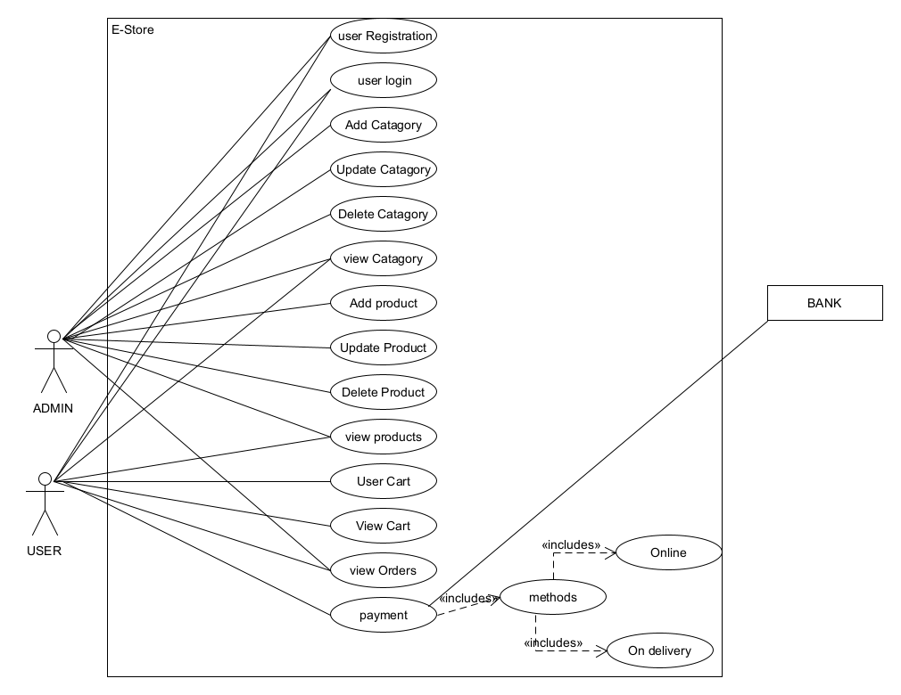

**User Characeristics:**

User should be familiar with the terms like login, register, order system etc.

**Principle Actors:**

2 Principle Actors are Customer and Administrator.

**General Constraints:**

A full internet connection is required for OSS.

**Assumptions and Dependencies**:

Working of OSS need Internet Connection.

**Domain Model**

